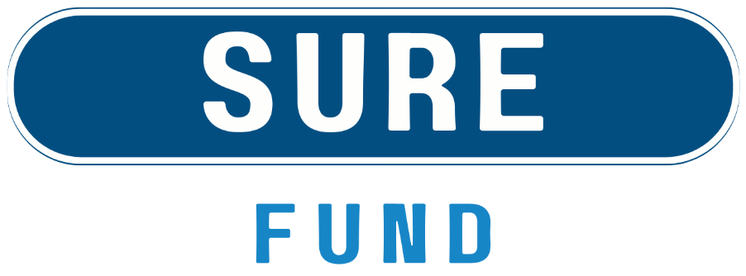

Application Form
April 2026

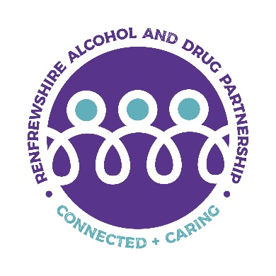



Renfrewshire Alcohol and Drug Partnership (ADP) brings together partners to reduce the harms caused by problematic alcohol and drug use.
As part of their ongoing commitment to applying a community led approach the ADP will work in partnership with Engage Renfrewshire to deliver a community grants programme (The SURE Fund) supporting grass root responses to preventing and reducing alcohol and drug related harm in Renfrewshire.
This investment is underpinned by a whole systems approach and the principles of local and national frameworks, with emphasis on lived and living experience, person-centred and trauma informed practice, harm reduction and community empowerment.
The Guidance can be found here: https://engagerenfrewshire.org/engage-support/sure-fund.html

Please keep answers to the stated word counts; applications that exceed the word count excessively will be asked to resubmit before consideration by the panel. Please ensure all questions are answered.

Section i – About Your Organisation
Organisation Name
Project Contact Name
Charity Number (if applicable)
Organisation Address
Telephone Number
Social media handles or website url:
Are you an existing Engage Renfrewshire member? | ☐ Yes  ☐ No  ☐ Not sure

Please select the category which describes the income per annum of your organisation:
☐ Organisation with income up to £5,000 | ☐ Organisation with income up to £10,000
☐ Organisation with income up to £25,000 | ☐ Organisation with income between £25,000 and £100,000
☐ Organisation with income between £100,000 and £500,000 | ☐ Organisation with income between £500,000 and £1 million
☐ Organisation with income over £1 million

We request banking details to streamline payment to successful groups, if unsuccessful banking evidence will not be kept on file.

Organisations should have a dedicated bank account, in the name of the organisation. Please also ensure you include evidence of your bank account with account name, number and sort code clearly shown when submitting your application.

Bank Name
Bank Account Name
Account Number
Sort Code

Please provide a brief description of your organisation’s overall work and how you support people in Renfrewshire (maximum 200 words)

Section ii – About your funding request
Does your project have a specific name? (Leave blank if just the name of your organisation)

Is your application for a new project or for a continuation/expansion of an existing project?
☐ New project
☐ Existing project

Is this a partnership project or joint-application?
☐ Yes *if selected please see additional questions in appendix i
☐ No

Please tick which of these descriptors best outlines your application for funding: Choose two
☐Individual mentoring | ☐Group peer support
☐Group counselling/talking therapy | ☐One to one counselling/talking therapy
☐Equipment purchase for group or maintenance/repair to infrastructure | ☐Food based project
☐Arts and crafts based project | ☐Sport or physical activity
☐ Environmental/nature based project

Which of the following priorities does your project contribute to (tick all that apply):
☐ Drug Prevention
☐ Alcohol Prevention
☐ Addiction Recovery

Is your project: for the general population (general), open to all but with a focus on particular target groups (targeted)? Choose one
☐ General
☐ Targeted

Project Aims & Objectives

Please outline how your project will make a difference to the people you support. (maximum 200 words)

Project activity
Please outline specific activities to be funded and how many people you hope to reach with each activity.

Include number of activities, locations of each activity and approximate date range/s (maximum 200 words)

How have you included the people you support in the design of this project? (maximum 150 words)

How will you measure the success of your project or expenditure? (maximum 150 words)

Section iii – Budgeting and other funding
Please use the below table to outline your budget breakdown - please only state what you are requesting from this fund, not total project budget.

The more detail provided the better, as this gives the panel a clearer understanding of the scope and scale of your project.

Please use the individual headings (as required) and then provide a total cost.

Description | Budgeted Cost (£)
Activity costs – please outline single-use resources to be purchased for promotion and delivery of activity (single use resources include as example: food, arts supplies, promotional posters)
Staff costs - please outline salary including hourly rate, national insurance contributions, pension contributions*, training costs*, subsistence/travel* (*if applicable)
Capital spend – any equipment to be purchased, or works undertaken
Overhead costs

TOTAL COST

Have you secured any match-funding for this project (for anytime during the period April 2026 to August 2027)?
☐ Yes
☐ No

Please state the value of matched funding secured for this project
£

Please state the name of the organisation/s providing matched funding

GRANT TERMS & CONDITIONS
By making an application to Engage Renfrewshire, you acknowledge that you are authorised to apply on behalf of your organisation and agree to the following terms and conditions.
You are authorised by your organisation to make this application.
To the best of your knowledge, all the information you have provided in your application gives a true and accurate account of your organisation’s work and needs.

Name

Role in organisation

Email

The form should be returned to info@engagerenfrewshire.com
no later than midday 13 May

Appendix i – joint or partnership application
Engage Renfrewshire welcome applications that make use of, and build upon, local knowledge and shared expertise. If you are making a joint application please respond to the below questions.
Please tell us about the partnership to date, outlining your decision making process to work collaboratively and any previous work (maximum 250 words)

Contact name at partner organisation

Role in organisation

Email

