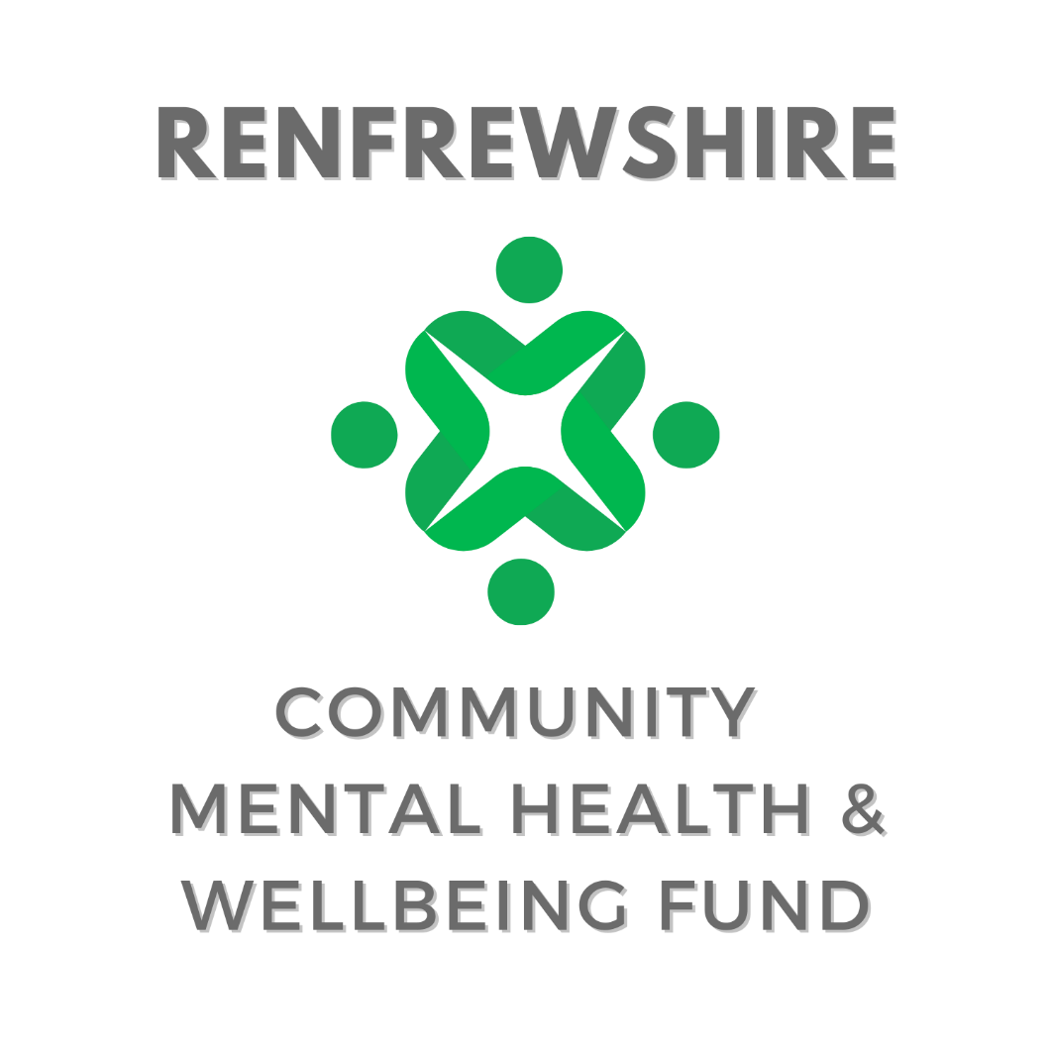

Single Year Application Form
September 2026

SAMPLE – NOT FOR SUBMISSION




The Community Mental Health and Wellbeing Fund has a strong focus on prevention and early intervention and aims to support grassroots community groups in tackling mental health inequalities and address priority issues of social isolation and loneliness, suicide prevention and tackling poverty and inequality. There will be a continued emphasis in Year 6 to the cost of living crisis and on those facing socio-economic disadvantage.
The overarching aim of the Fund is to: support community based initiatives that promote and develop good mental health and wellbeing and/or mitigate and protect against the impact of distress and mental ill health within the adult population (aged 16 or over), with a particular focus on prevention and early intervention.
Please note: this application period covers activity in 2027 only. When composing your application and budget please be mindful that successful groups will be notified by end of December 2026.
The Guidance and Funding Examples can be found on our dedicated webpage – Community Mental Health and Wellbeing Fund
Please keep answers to the stated word counts. This document is to aid in drafting an application only. All submissions should, where possible, be made via the Jotform link found at the above webpage.

Section i – About Your Organisation
Organisation Name
Project Contact Name
Charity Number
Organisation Address
Organisation Post Code
Telephone Number
Social media handles or website url:
Are you an existing Engage Renfrewshire member? | ☐ Yes  ☐ No  ☐ Not sure

Please provide a brief description of your organisation’s work and how you support people in Renfrewshire (maximum 200 words)

Please select the category which describes the income per annum of your organisation:
☐ Organisation with income up to £5,000 | ☐ Organisation with income up to £10,000
☐ Organisation with income up to £25,000 | ☐ Organisation with income between £25,000 and £100,000
☐ Organisation with income between £100,000 and £500,000 | ☐ Organisation with income between £500,000 and £1 million
☐ Organisation with income over £1 million

We request banking details to streamline payment to successful groups, if unsuccessful banking evidence will not be kept on file.

Please upload a screenshot or photograph of a recent account statement or cheque book so we can cross-check the above information.
Bank Name
Bank Account Name
Account Number
Sort Code

Section ii – About your funding request
Does your project have a specific name? (Leave blank if just the name of your organisation)

Is your application for a new project or for a continuation/expansion of an existing project?
☐ New project
☐ Existing project (funded through this fund)*if selected please see additional questions in appendix i
☐ Existing Project (new application to this fund but supported currently/previously by another fund)

Is this a partnership project or joint-application?
☐ Yes *if selected please see additional questions in appendix ii
☐ No

Please enter the number of volunteers involved in delivering the project

Please tick which of these project descriptors best outlines your project: Choose one
☐ Arts and crafts | ☐ Befriending
☐ Counselling | ☐ Culture
☐ Equipment | ☐ Financial inclusion/cost of living
☐ Food | ☐ Group activity
☐ Maintenance/repair | ☐ Mentoring
☐ Nature | ☐ One to one
☐ Peer support | ☐ Social
☐ Sport or physical activity | ☐ Therapeutic
☐ Other
If selecting Other, please note the project type here:

Please describe the project including its key aims and activities, and how this supports mental health and wellbeing (maximum 100 words)

Please outline any specific activities to be funded and how many people you hope to reach with each activity. Include number of activities, locations of each activity and approximate date range/s (maximum 200 words)

Please confirm in which Local Partnership Area your project will take place - please refer to the Renfrewshire Council website for area boundaries. Tick all that apply:
☐ Inchinnan, Erskine, Bishopton and Langbank
☐ Gleniffer
☐ Johnstone and Linwood
☐ Paisley North, West and Central
☐ Paisley East
☐ Renfrew
☐ The Villages
☐ Renfrewshire Wide
☐ Online

Which of the following priorities does your project contribute to (tick all that apply):
☐ Suicide prevention
☐ Social isolation/loneliness
☐ Addressing poverty and inequality

Is your project: for the general population (general), open to all but with a focus on particular target groups (targeted) or aimed directly at particular target groups (restricted)? Choose one
☐ General
☐ Targeted
☐ Restricted

Please indicate which of the below priority groups your project is targeting? Choose a maximum of three.
☐ Women (particularly young women, and women and young women affected by male sexual violence) | ☐ People with a long term health condition or disability
☐ People from ethnically diverse background | ☐ Refugees and those with no recourse to public funds
☐ People facing socio-economic disadvantage | ☐ People experiencing severe and multiple disadvantage
☐ People with diagnosed mental illness | ☐ People affected by psychological trauma (including adverse childhood experiences)
☐ People who have experienced bereavement or loss | ☐ People disadvantaged by geographical location (particularly remote and rural areas)
☐ Older people (aged 50 and above) | ☐ People with neurological conditions or learning disabilities, and from neurodiverse communities
☐ Lesbian, Gay, Bisexual and Transgender and Intersex (LGBTI) communities | ☐ Young people aged 16 - 24

How have you included the people you support in the design of this project? (maximum 200 words)

The following family types are considered to be most at risk of poverty. Please select any (or all) who are highly likely to engage with this project. NB: This question is for monitoring only, and will not impact panel decisions.
☐ Lone parents | ☐ Families with a disabled family member
☐ Families with 3+ Children | ☐ Minority ethnic families
☐ Families where the youngest children are under 1 year old | ☐ Mothers aged less than 25

How will you measure the success of your project or expenditure? (maximum 150 words)

Section iii – Budgeting and other funding
Please use the below table to outline your budget breakdown - please use the table to only state what you are requesting from this fund, a question on total project cost is below. The more detail provided the better, as this gives the panel a clearer understanding of the scope and scale of your project.

Please describe the item/resource/cost you're planning to buy | Budgeted Cost (£)
TOTAL COST
What is the total cost of the project you are applying for?
£

Have you secured any match-funding for this project (up to March 2026)?
☐ Yes
☐ No

Please state the value of matched funding secured for this project
£

Please state the name of the organisation/s providing matched funding

GRANT TERMS & CONDITIONS By making an application to Engage Renfrewshire, you acknowledge that you are authorised to apply on behalf of your organisation and agree to the following terms and conditions.
You are authorised by your organisation to make this application.
To the best of your knowledge, all the information you have provided in your application gives a true and accurate account of your organisation’s work and needs.
Name

Role in organisation

Email

The form should be submitted via Jotform no later than 11:59pm on 30th October

Appendix i – Previously funded projects
Please only fill in the below if you are applying for funds to continue a project/activity/event we previously funded. If you are applying for a new project you do not need to fill in the below.
Please tell us about the project so far, outline any particular successes or changes from your first application and if you project any underspend (maximum 300 words – you may use graphs and attach up to 10 photographs/videos to your application to help illustrate the impact)

Appendix ii – joint or partnership application
Engage Renfrewshire welcome applications that make use of, and build upon, local knowledge and shared expertise. If you are making a joint application please respond to the below questions.
Please tell us about the partnership to date, outlining your decision making process to work collaboratively and any previous work (maximum 250 words)

Contact name at partner organisation

Role in organisation

Email

