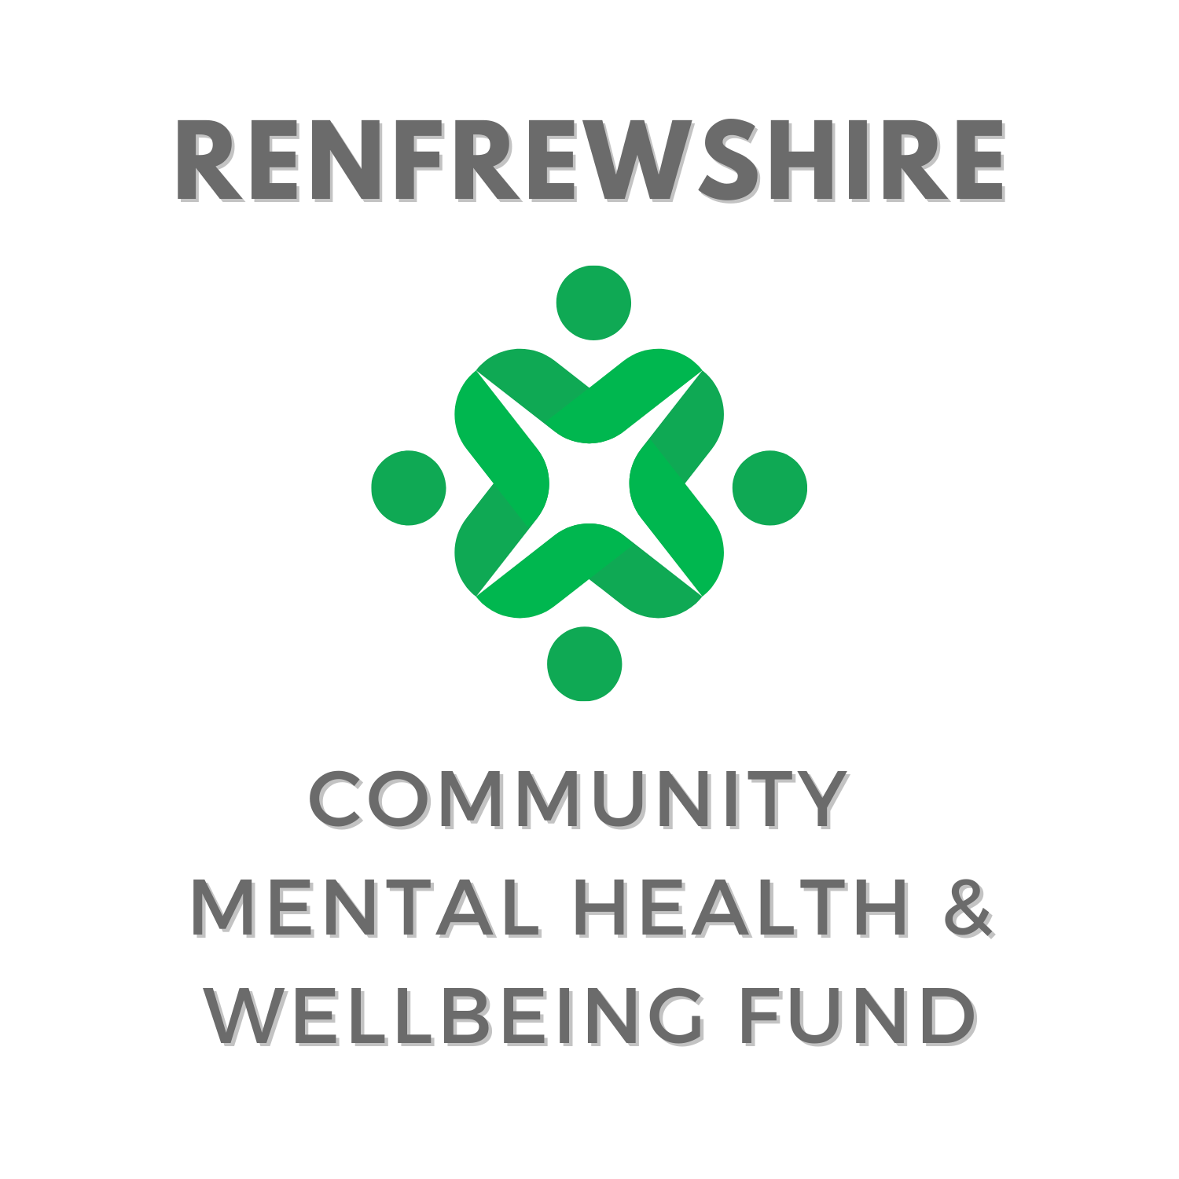

**Single Year Application Form**

**August 2025**



The Communities Mental Health and Wellbeing Fund for Adults (the Fund) was established in October 2021 and to date has distributed around £66 million to community initiatives supporting mental health and wellbeing across Scotland. In Renfrewshire the fund has seen over £2 million distributed to organisations, community groups and community projects.

The Fund has a strong focus on prevention and early intervention and aims to support grass roots community groups in tackling mental health inequalities and address priority issues of social isolation and loneliness, suicide prevention and tackling poverty and inequality. There will be a continued emphasis in Year 5 to the cost of living crisis and on those facing socio-economic disadvantage.

The overarching aim of the Fund is to: support community based initiatives that promote and develop good mental health and wellbeing and/or mitigate and protect against the impact of distress and mental ill health within the adult population (aged 16 or over), with a particular focus on prevention and early intervention.

Applications will be accepted from a range of voluntary, ‘not for profit’ organisations, associations, groups and clubs or consortiums/partnerships which have a strong community focus for their activities.

The Guidance and Funding Examples can be found on our dedicated webpage – [Community Mental Health and Wellbeing Fund](https://engagerenfrewshire.org/engage-support/community-mental-health-wellbeing-fund.html)

**Please keep answers to the stated word counts; applications that exceed the word count excessively will be asked to resubmit before consideration by the panel. Please ensure all questions are answered.**

**Section i – About Your Organisation**

|  |  |
| --- | --- |
| Organisation Name |  |
| Project Contact Name |  |
| Charity Number |  |
| Organisation Address |  |
| Telephone Number |  |
| Social media handles or website url: |  |
| Are you an existing Engage Renfrewshire member? | Yes  No  Not sure |

|  |  |
| --- | --- |
| Please select the category which describes the income per annum of your organisation: | |
| Organisation with income up to £5,000 | Organisation with income up to £10,000 |
| Organisation with income up to £25,000 | Organisation with income between £25,000 and £100,000 |
| Organisation with income between £100,000 and £500,000 | Organisation with income between £500,000 and £1 million |
| Organisation with income over £1 million | |

|  |  |
| --- | --- |
| We request banking details to streamline payment to successful groups, if unsuccessful banking evidence will not be kept on file.  *Organisations should have a dedicated bank account, in the name of the organisation. Please also ensure you include evidence of your bank account with account name, number and sort code clearly shown when submitting your application.* | |
| Bank Name |  |
| Bank Account Name |  |
| Account Number |  |
| Sort Code |  |

|  |
| --- |
| Please provide a brief description of your organisation’s work and how you support people in Renfrewshire (maximum 200 words) |
|  |

**Section ii – About your funding request**

|  |
| --- |
| Does your project have a specific name? (Leave blank if just the name of your organisation) |
|  |

|  |
| --- |
| Is your application for a new project or for a continuation/expansion of an existing project? |
| New project  Existing project (funded through the Communities Fund)*\*if selected please see additional questions in appendix i*  Existing Project (New to Communities Fund but funded previously through another grantee) |

|  |
| --- |
| Is this a partnership project or joint-application? |
| Yes *\*if selected please see additional questions in appendix ii*  No |

|  |
| --- |
| Please enter the number of volunteers involved in delivering the project |
|  |

|  |  |
| --- | --- |
| Please tick which of these project descriptors best outlines your project: Choose one | |
| Befriending | Peer support |
| Counselling | Therapeutic |
| Mentoring | Financial inclusion/cost of living |
| One to one | Group activity |
| Equipment | Food |
| Nature | Social |
| Arts and crafts | Maintenance/repair |
| Sport or physical activity | Culture |
| Other  If selecting Other, please note the project type here: | |

|  |
| --- |
| Please describe the project including its key aims and activities, and how this supports mental health and wellbeing (maximum 100 words) |
|  |

|  |
| --- |
| Please outline any specific activities to be funded and how many people you hope to reach with each activity. Include number of activities, locations of each activity and approximate date range/s (maximum 200 words) |
|  |

|  |
| --- |
| Which of the following priorities does your project contribute to (tick all that apply): |
| Suicide prevention  Social isolation/loneliness  Addressing poverty and inequality |

|  |
| --- |
| Is your project: for the general population (general), open to all but with a focus on particular target groups (targeted) or aimed directly at particular target groups (restricted)? Choose one |
| General  Targeted  Restricted |

|  |  |
| --- | --- |
| Please indicate which of the below priority groups your project is targeting? Choose a maximum of three. | |
| Women (particularly young women, and women and young women affected by male sexual violence) | People with a long term health condition or disability |
| People from ethnically diverse background | Refugees and those with no recourse to public funds |
| People facing socio-economic disadvantage | People experiencing severe and multiple disadvantage |
| People with diagnosed mental illness | People affected by psychological trauma (including adverse childhood experiences) |
| People who have experienced bereavement or loss | People disadvantaged by geographical location (particularly remote and rural areas) |
| Older people (aged 50 and above) | People with neurological conditions or learning disabilities, and from neurodiverse communities |
| Lesbian, Gay, Bisexual and Transgender and Intersex (LGBTI) communities | |

|  |
| --- |
| How have you included the people you support in the design of this project? (maximum 200 words) |
|  |

|  |  |
| --- | --- |
| The following family types are considered to be most at risk of poverty. Please select any (or all) who are highly likely to engage with this project. *NB: This question is for monitoring only, and will not impact panel decisions.* | |
| Lone parents | Families with a disabled family member |
| Families with 3+ Children | Minority ethnic families |
| Families where the youngest children are under 1 year old | Mothers aged less than 25 |
| How will you measure the success of your project or expenditure? (maximum 150 words) | |
|  | |

**Section iii – Budgeting and other funding**

|  |
| --- |
| Please use the below table to outline your budget breakdown - please only state what you are requesting from this fund, not total project budget. *The more detail provided the better, as this gives the panel a clearer understanding of the scope and scale of your project.* |

|  |  |
| --- | --- |
| **Description** | **Budgeted Cost** (£) |
|  |  |
|  |  |
|  |  |
|  |  |
|  |  |
|  |  |
|  |  |
|  |  |
|  |  |
|  |  |
|  |  |
|  |  |
|  |  |
|  |  |
|  |  |
|  |  |
| TOTAL COST |  |

|  |
| --- |
| Have you secured any match-funding for this project (up to March 2026)? |
| Yes  No |

|  |
| --- |
| Please state the value of matched funding secured for this project |
| £ |

|  |
| --- |
| Please state the name of the organisation/s providing matched funding |
|  |

**GRANT TERMS & CONDITIONS**

By making an application to Engage Renfrewshire, you acknowledge that you are authorised to apply on behalf of your organisation and agree to the following terms and conditions.

You are authorised by your organisation to make this application.

To the best of your knowledge, all the information you have provided in your application gives a true and accurate account of your organisation’s work and needs.

|  |  |
| --- | --- |
| Name |  |
| Role in organisation |  |
| Email |  |

**The form should be returned to** [**info@engagerenfrewshire.com**](mailto:info@engagerenfrewshire.com) **no later than 5pm on October 1st**

Appendix i – Previously funded projects

**Please only fill in the below if you are applying for funds to continue a project/activity/event we previously funded. If you are applying for a new project you do not need to fill in the below.**

|  |
| --- |
| Please tell us about the project so far, outline any particular successes or changes from your first application and if you project any underspend (maximum 300 words – you may use graphs and attach photographs/videos to your application to help illustrate the impact) |
|  |

Appendix ii – joint or partnership application

**Engage Renfrewshire welcome applications that make use of, and build upon, local knowledge and shared expertise. If you are making a joint application please respond to the below questions.**

|  |
| --- |
| Please tell us about the partnership to date, outlining your decision making process to work collaboratively and any previous work (maximum 250 words) |
|  |

|  |  |
| --- | --- |
| Contact name at partner organisation |  |
| Role in organisation |  |
| Email |  |