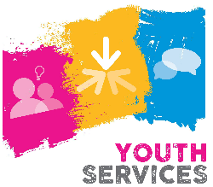
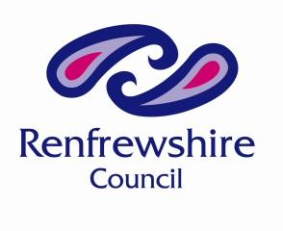
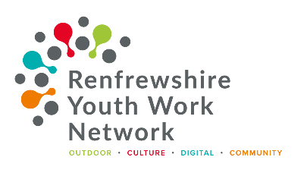

PDA in Youth Work Application Form – Renfrewshire 2023 Course.

Your Contact Details: Please enter the details of where you wish us to contact you. This may be your work address or your home address. Please ensure that you give us a mobile number, as we may have to contact you at evenings or weekends.

PROVIDING A PERSONAL EMAIL ADDRESS IS AN ADVANTAGE AS COURSE RELATED MATERIAL MAY BE SENT TO YOU BETWEEN SESSIONS. THIS EMAIL ADDRESS WILL ONLY BE USED FOR PDA RELATED EMAILS.

About you:
Name: | D.O.B: |  | SQA Candidate No:
Address:

Tel: |  | Mobile:
Email:
Job role/ title:
Full-time/Part-Time/Volunteer :

About your organisation:

Group/Organisation Name:
Address:

Tel: | Youth Scotland Membership No. (if applicable): 350/ _ _ _ _ _

Is this group/organisation where you will undertake your youth work observed practice?

Line manager or person in charge of group where you work/volunteer

Name:
Tel:
Email:
Job Title/Role:

Special Requirements:

Special requirements: If you have any specific dietary, learning support, access or other requirements please describe them here.

Personal Statement:

Please describe your previous and current experience of youth work and what you hope to get out of undertaking this PDA in Youth Work course. This will be used as part of selection, so give as much information as possible: (Up to 300 words) NB/ You should include the age-range of young people you have worked with, the kind of settings you have worked in, how long you have been working/volunteering and what your roles have involved.

Education:

Please provide some information about your previous experience of education, including any qualifications you may have undertaken at school/college/work/volunteering.

In addition provide evidence of how you meet the minimum criteria to access this course.

Application Checklist

I understand that if I am accepted on this PDA in Youth Work course, I will be required to:

- Register with SQA (Youth Scotland will do this for you as part of the course registration)
- Attend all the course session sessions listed below

Course Timetable - All sessions will be held in Foxbar Youth Centre

Information Evening |  |  | Monday 6th February 2023 |  | 6pm – 7pm
Unit 1 |  | Day 1 | Saturday 4th March 2023 |  | 10am – 4.30pm
 |  | Day 2 | Saturday 11th March 2023 |  | 10am – 4.30pm
Unit 2 |  | Day 1 | Saturday 22nd April 2023 |  | 10am – 4.30pm
 |  | Day 2 | Saturday 29th April 2023 |  | 10am – 4.30pm
Unit 3 |  | Day 1 | Saturday 20th May 2023 |  | 10am – 4.30pm
 |  | Day 2 | Saturday 3rd June 2023 |  | 10am – 4.30pm

Observed Practice session to be arranged between 22nd May – 2nd June – Dates to agreed with organisation and young people.

Assessment Due Dates (dates assessments have to be handed in by):
- Unit 1: Monday 3rd April 2023
- Unit 2: Monday 15th May 2023
- Unit 3: Monday 19th June 2023
A detailed programme for each of the sessions will be given to candidates at the start of each unit.

- I have the permission of my workplace/ place where I volunteer to deliver a youth work session to young people and be observed doing for Unit 3.

Signed (Candidate):
Date:

For Line Manager or Volunteer Supervisor:

I support the candidate’s application. I agree to support them on the PDA programme, including arrangements to carry out the required Observed Practice session and act as their mentor as required.

Signed (Line Manager or Volunteer Supervisor):

Date:

Please complete the attached PDA Renfrewshire course application form and return to: youth@renfrewshire.gov.uk

- Application forms must be completed and signed by the applicant.
- Application forms must be returned by no later than 5pm on Friday 10th Feb 2023
- Successful applicants will be advised by Friday 17th February 2023
- A formal acceptance form will be sent out to those offered places which must be completed and returned asap.
- The first session of the course will take place in person on Saturday 4th March 2023,
10am – 4.30pm at Foxbar Youth Centre

For further information about the Renfrewshire PDA in Youth Work course contact:

Renfrewshire Council Youth Services youth@renfrewshire.gov.uk
Tel: 07506966776

Michele Meehan, Youth Scotland Michele.meehan@youthscotland.org.uk
Tel: 0131 554 2561/ 07816300183 – please leave message if no answer

