***The aim of this grants programme is to support people to move toward, into, and within work. To do this, we need to help local people to develop the skills and confidence employers are looking for. To reach those people, we all need to work together at a local level to provide the best possible services to those who need them most.***

Ruth Cooper, Economic Development Manager, Renfrewshire Council and Chair of Renfrewshire Local Employability Partnership

Renfrewshire Employability Grants Programme Delivery Period April 2025 – March 2026 Key Information, Guidance, and Sources of Useful Data

EconoMic Development team, Renfrewshire Council |  on behalf of Renfrewshire Local Employability Partnership

Round 4: 2025-26

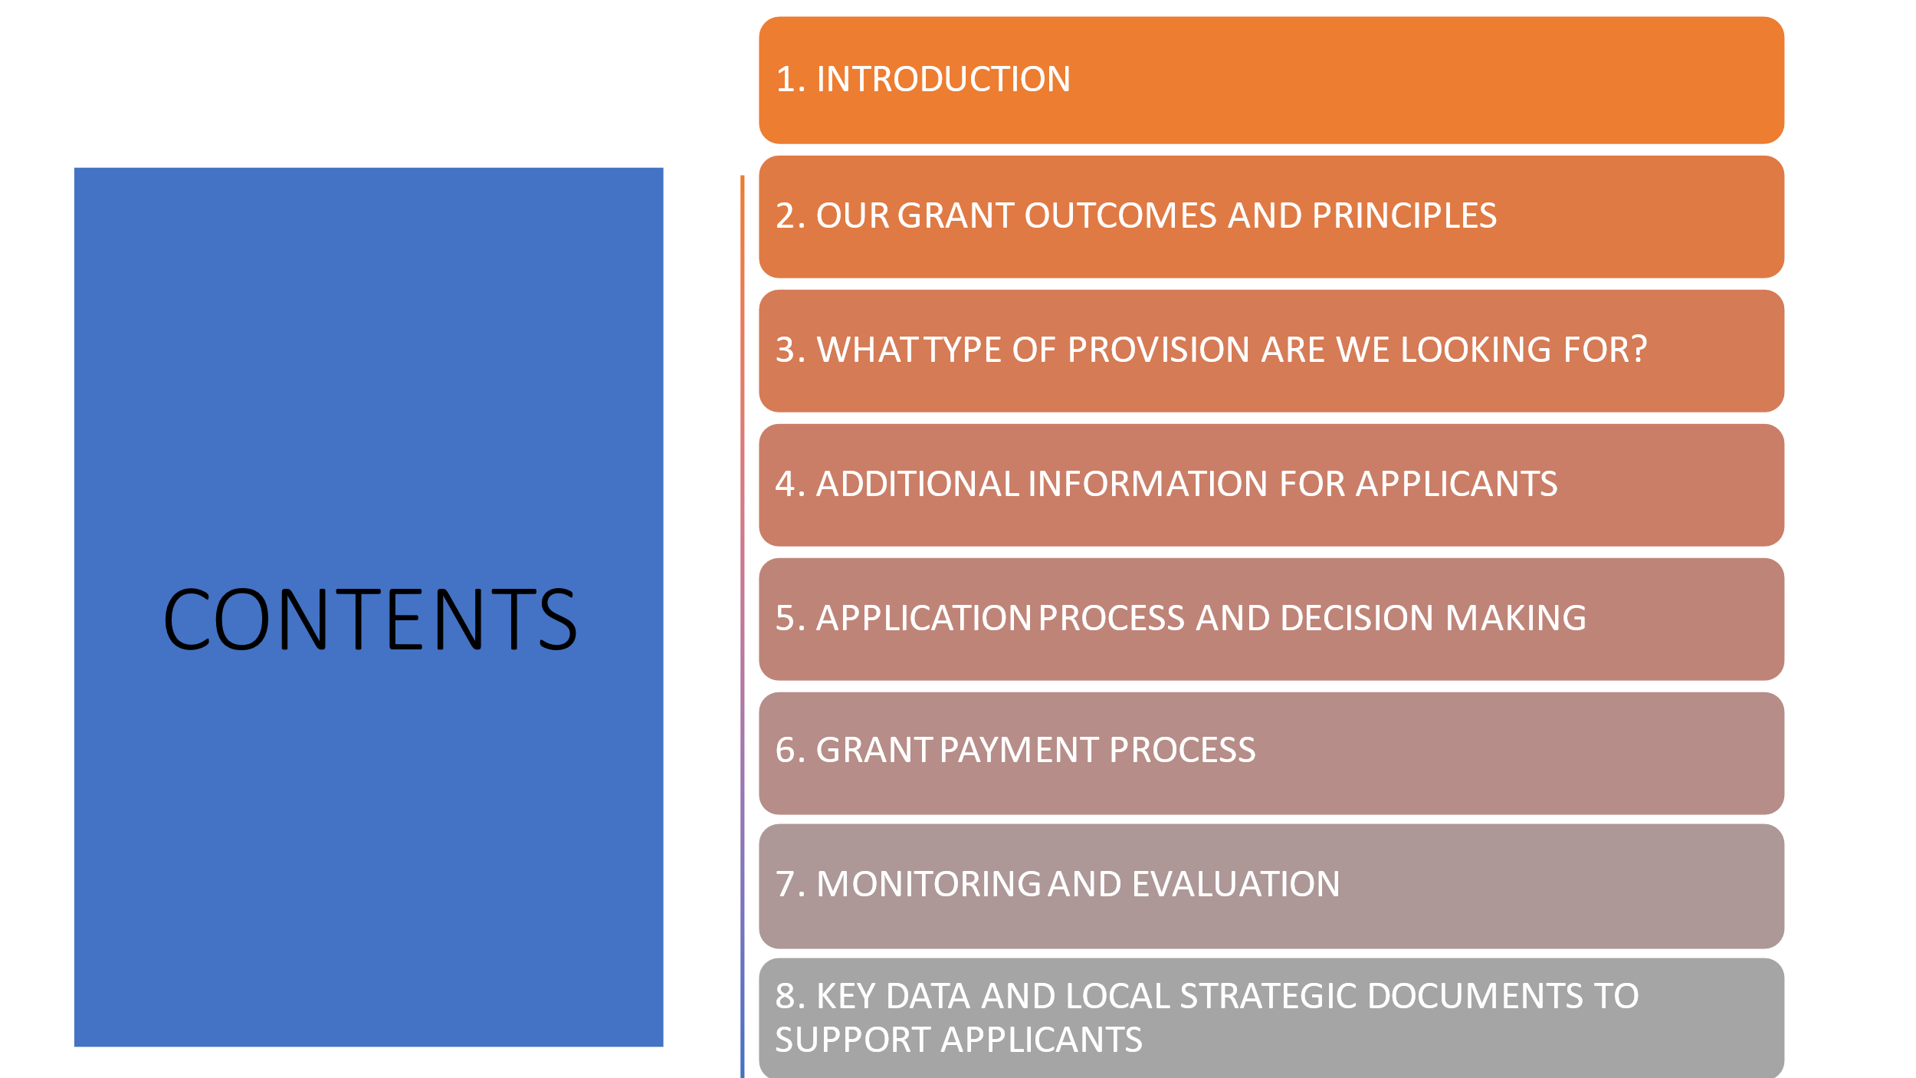

1. **Introduction and context**

The Renfrewshire Employability Grants Programme aims to support unemployed, economically inactive and low paid people to move towards, into, and within work. It recognises that to help local people to develop the skills and confidence employers are looking for, we all need to work together at a local level to provide the best possible services to those who need them most.

There have been, and will continue to be, changes in how employability support is funded in Scotland. Both the Scottish and UK Governments are choosing to distribute funding at a more local level and through a Local Employability Partnership (LEP). This partnership decides on the local priorities and areas for action, and also ensures that local employability providers continue to have the opportunity to access funding for services through a co-commissioned process. The key Scottish Government policy framework for this approach is called **No One Left Behind (NOLB),** and this will guide the future direction and delivery of employability services in the years to come.

In Renfrewshire the strategic partnership is the **Renfrewshire LEP** consisting of partner agencies from the Renfrewshire Community Planning Structure. The LEP is chaired by Renfrewshire Council, and has met as an active partnership for around 13 years. Its purpose is to support the implementation of local and national employability policy through collective leadership, joint planning, and co-commissioning. Working closely with local delivery partners, the partnership seeks to make the best use of resources available to deliver effective needs-led employability services that help Renfrewshire residents make a successful transition towards employment.

**This information document and the application form will be published on the Renfrewshire Local Employability Partnership pages on the Invest in Renfrewshire website –** [**https://investinrenfrewshire.com/renfrewshire-local-employability-partnership-rlep/**](https://investinrenfrewshire.com/renfrewshire-local-employability-partnership-rlep/)(scroll to How RLEP Commissions)**from Friday 20th December 2024. Deadline for applications is midnight on Friday 31st January 2025. (Further details on the full timetable of the grants application process are contained in section 5).**

***The Renfrewshire Employability Grants Programme***

In 2021, RLEP agreed to establish an Employability Grants Programme for Renfrewshire to support a co-commissioned approach to employability for future years and this was approved through the Renfrewshire Council Leadership Board in September 2021. This is the 4th annual grants programme for the period April 2025 to March 2026. It will continue to fund provision that:

* Augments the employability provision delivered by DWP, Skills Development Scotland, Renfrewshire Council’s Invest Employability Services, and other partners.
* Adds value to the funding and other resources already available locally and creates opportunities for innovation and collaboration.
* Supports the aims and objectives outlined in the Renfrewshire Economic Strategy, the Renfrewshire Economic Recovery Plan, and No One Left Behind.

**At this point in time, we anticipate a budget of around £1m however, as funding is not yet confirmed, this figure may change.**

Funds that will contribute to this round are as follows:

|  |  |
| --- | --- |
| **Period** | **Grant Sources** |
| **2025/26** | Renfrewshire Council Employability Funding  Scottish Government No One Left Behind (NOLB); Child Poverty (Parental Employment Support)and Specialist Employability Support  UK Government Shared Prosperity Funding |

***The Renfrewshire Core Employability Offer***

The Grants Programme is designed to complement and augment a core Renfrewshire Employability Offer delivered by Renfrewshire Council’s ‘Invest’ team. This service is summarised in the diagram below.

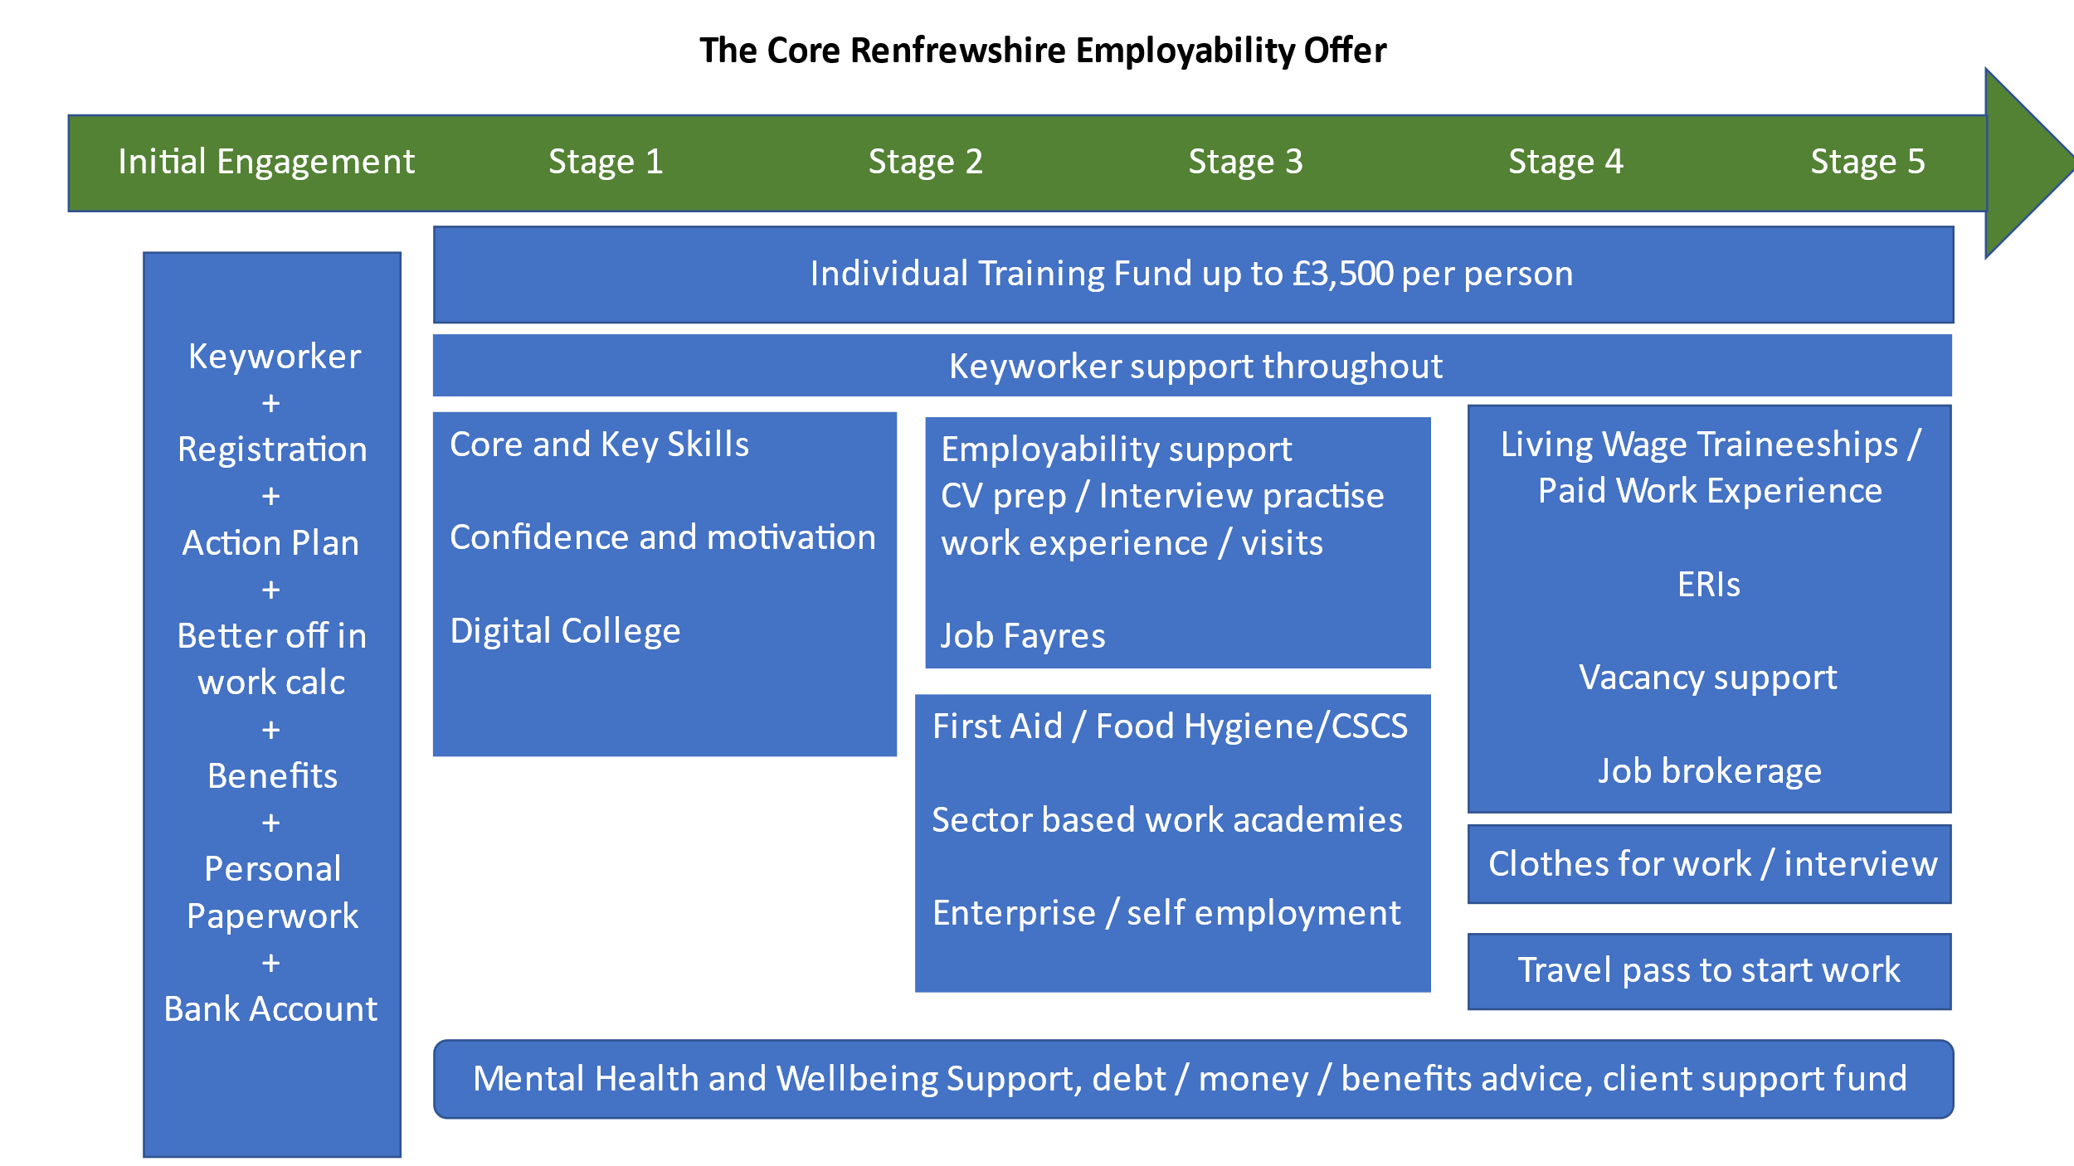

1. **Our Grant Outcomes and Principles**

The Renfrewshire Employment Grant Programme will contribute to **4 key outcomes**:

* **Reduce unemployment and economic inactivity levels.**
* **Reduce the gap in unemployment/employment rates for targeted geographies and groups.**
* **Ensure that our residents have the appropriate skills and are suitably prepared and informed to match those required by local businesses and others within reach.**
* **Contribute to reducing child poverty through increasing income from employment for (low income) parents**

**6 NOLB principles** that will underpin the delivery expectations for all provision supported via the Renfrewshire Employability Grants Programme.

1. Provide flexible and person-centred support.
2. Be more straightforward for people to navigate.
3. Be better integrated and aligned with other services, particularly with health, justice, and housing provision.
4. Provide pathways into sustainable and fair work.
5. Be driven by evidence, including data and the experience of users.
6. Support more people – particularly those facing multiple barriers – to move into the right job, at the right time.

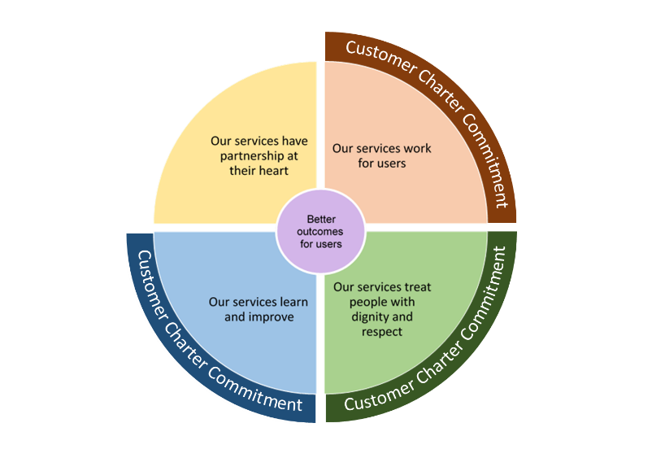In addition, all providers supported through the grants programme will need to evidence how their service/provision reflects the Scottish **Employability Service Standards** <https://www.employabilityinscotland.com/news-events/news/employability-service-standards-published/>

These standards were established to ensure a level of consistency across Scotland - without negatively impacting on local flexibility to deliver for people accessing services, or in a way that reflects local labour markets. The Standards set out a number of expectations, but partners can implement many of these in a variety of ways. Organisations should go further if there is the capacity and desire to do so.

Each Standard should not be viewed in isolation. There are areas of overlap, but delivered together, these are designed to achieve the common purpose of delivering better outcomes for users.

All delivery partners will also be required to provide copies of the Renfrewshire Employability Services Customer Charter to all participants. This sets out what service users can expect when accessing employment services, what employment services will do to achieve this and how users can ensure the commitments are being met. There is a link to our Customer Charter on the LEP webpage : <https://investinrenfrewshire.com/renfrewshire-local-employability-partnership-rlep/>

All providers are also required to comply with the following **additional principles** that the RLEP feel are critical in providing the best support to people to enable progress towards sustainable outcomes.

* Services should be configured around the needs of the clients, rather than delivery partners.
* Face to face provision should be the being the main delivery model, unless the target group or individuals request or require otherwise.
* Services should be delivered locally (within Renfrewshire).
* ‘Travel to work’ opportunities should be considered with participants to help overcome barriers (both physical and perceived), and to support access to opportunities out-with their local area, across Renfrewshire and the wider Glasgow City Region.
* Grant recipients should be able to demonstrate how they will become an active partner in an integrated Renfrewshire employability offer, making use of the Renfrewshire Local Employability Partnership resources such as training and development activity and events, and Renfrewshire Practitioners and Delivery Partners forums.
* Applicants should also make use of the RLEP web pages within the Invest Renfrewshire website and associated social media platforms to advertise activities and promote regular good news stories. This will include posting all provision funded through the grants programme on the Skills and Training network portal [https://skillstrainingnetwork.org/invest-in-renfrewshire/](https://eur01.safelinks.protection.outlook.com/?url=https%3A%2F%2Fskillstrainingnetwork.org%2Finvest-in-renfrewshire%2F&data=05%7C02%7Ckay.mcintosh%40renfrewshire.gov.uk%7C071939dd2f7641563a2d08dc0073e96c%7Cca2953361aa64486b2b2cf7669625305%7C0%7C0%7C638385745025574019%7CUnknown%7CTWFpbGZsb3d8eyJWIjoiMC4wLjAwMDAiLCJQIjoiV2luMzIiLCJBTiI6Ik1haWwiLCJXVCI6Mn0%3D%7C3000%7C%7C%7C&sdata=mlkSPbioFFEGuXykP43QEZjkU9fbGeKcKLgnzsJV9Kw%3D&reserved=0) . More information and training on this will be made available with grant award documentation. Grant recipients will also have to provide fact sheets for each programme for use by front line staff. A template will be provided.
* Grant recipients should ensure that the design of services has considered the needs of those with protected characteristics.
* Services provided with grant support should provide additionality to existing provision available in Renfrewshire with connectivity, where permissible, to established provision and building progression routes into Further/Higher Education, Modern and Graduate Apprenticeships and other appropriate provision, as well as supporting access to employment.
* Provision must not put at risk participants current eligibility for benefits, or lead to a reduction in their overall income.

1. **What Type of Provision are we looking for?**

This grant programme will support **provision across all 5 stages of Renfrewshire’s employability pipeline** for unemployed and economically inactive Renfrewshire residents, particularly those furthest from the labour market and/or for whom the current employability service provision does not fully meet their needs. It will also support provision for low-income parents to help them progress within work and increase their income.

|  |  |  |  |  |
| --- | --- | --- | --- | --- |
| Stage 1 | Stage 2 | Stage 3 | Stage 4 | Stage 5 |
| **Engagement** | **Support to overcome barriers** | **Vocational activity** | **Employer engagement and job matching** | **In work support and aftercare** |

Having undertaken significant engagement with a wide range of stakeholders and analysed local data including the performance of the first 3 rounds of grant funded programmes, the LEP has identified 8 priority themes that it would like to focus its co-commissioning on through this grants programme.

This also takes cognisance of our core employability services in the area supported through other budgets/statutory provision (as outlined on page 3)**.** Around **2000 Renfrewshire residents are receiving support through the LEP’s core offer each year**. Invest **Keyworkers** play a crucial role in providing support throughout participants employability journeys, including helping them to navigate the provision available. **The LEP Grants funded provision must be complementary to this.**

Of the 2000 people supported each year, the charts below provide a basic demographic overview for those active at October 2024 (726 clients).

Some additional data relating to our target groups to be supported through commissioned provision is provided in the table following this information, within the commissioning plan.

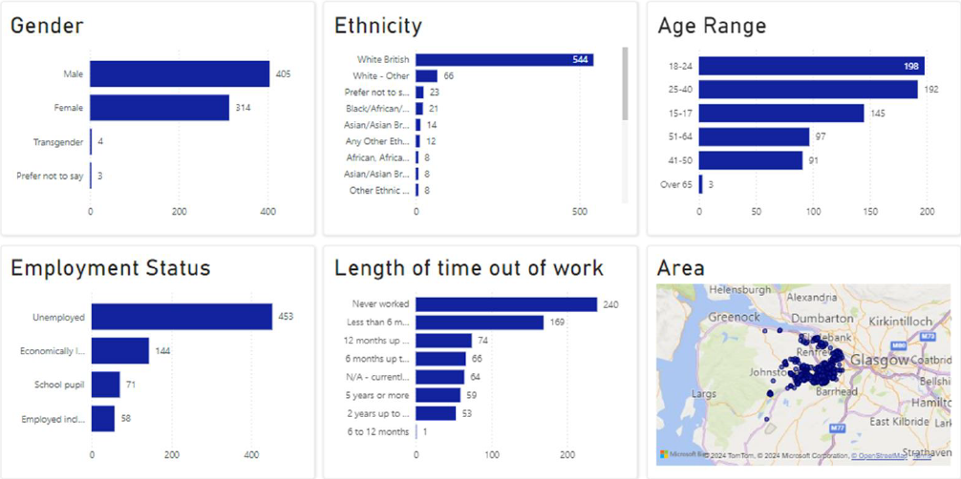

Employability Grants Programme Themes and Requirements 2025-26

|  |  |  |  |  |
| --- | --- | --- | --- | --- |
| **Commissioning Plan**  **Priority Groups/Themes** | **Rationale/evidence of need /useful data** | **Pipeline Stages** | **Fundable Provision** | **Indicative   Budget and Places** |
| 1. **People for whom a lack of English language skills is impacting on their ability to progress into work** | Housing, employability, college and community learning services report an ongoing high demand for English language support and waiting lists.  Employability services report a significant increase in the numbers of clients from minority ethnic groups engaging often with poor/low English language skills, a key barrier to employment.  This year we have been working with around 400 people from minority ethnic groups. The table below is a snapshot showing those being supported at this moment .  CLD and the local college deliver ESOL however our needs assessment for employability clients suggest that **there is a need for conversational classes/support, both generic as well as sector specific.** | 1/2 | **1.1** Innovative and effective programmes that develop the English **speaking skills** of refugees, asylum seekers, or other minority groups to enable them to access and sustain employment.  Whether ESOL or otherwise, the key need is to develop participants **conversational English** in **suitable learning environments** where participants with a range of abilities can develop confidence and ability. | **40 places.** |
| 1. **Unemployed residents requiring vocational skills to progress into employment** | The LEP recognises the need to provide vocational skills training in sectors where there are likely to be vacancies over the coming year.  The aspiration of the LEP is to support those gaining vocational skills to progress into related and sustainable work opportunities in Renfrewshire, or within other reasonably accessible travel to work areas.  We have an all age offer in Renfrewshire and of the 2000 or so people accessing our LEP services each year, around a half require vocational training. Some of this can be met through accessing training on an individual basis however we require a wide range of relevant vocational courses for groups of clients to meet client and employer needs. | 3/4 | **2.1** Delivery of 4 -12 week **vocational skills** programmes/sector based work academies, which are linked to local employers and evidenced work opportunities.  Programmes must include industry recognised qualifications/certificates; 2 weeks work experience and guaranteed interviews.  Much of what we commission will be **all age and open to all target groups**  however we need to ensure our provision meets the specific needs of our priority groups who may benefit from a more targeted and bespoke programme ,in particular :  **Parents** – who need training provision and jobs with school /parent friendly hours and conditions.  **School leavers up to 19yrs** who require vocational programmes adapted to meet their specific needs and job opportunities including apprenticeships.  Applicants may opt to deliver vocational programmes for all ages (no specific target group) and/or courses bespoke for parents or young people. | **175 places** |
| 1. **Unemployed people or low- income residents wishing to pursue self- employment** | There is an ongoing demand for self-employment support, particularly from people whose circumstances make self-employment a more realistic and sustainable employment option e.g. parents and carers, people with health conditions etc. | 3-5 | **3.1** **Self-employment training programme/s** that will enable participants to establish their self-employment businesses and give them an opportunity to test trade. In addition to specialist training, mentoring will be key to success. | **20 places** |
| 1. **Unemployed or economically inactive people with disabilities or long-term conditions** | Of the 2000 clients supported each year via LEP services and provision, the figures below is a snapshot of the current caseload recording a disability or long term condition – which is about half of those supported across the full year.  A current profile of the Invest/LEP caseload shows:   * Autistic Spectrum Disorder / Condition 58 * Sight /hearing/speech impairment 10 * Learning difficulty 40 * Learning disability 26 * Other developmental disorder 10 * Physical disability 44   In addition to key worker support, Project Search has operated effectively in Renfrewshire for 10 years and commissioned provision enhances our service offer to those with disabilities/long term conditions. | 1-5 | **4.1** **All stage supported employment programme** for people (all age) with autism or a complex learning/physical disability who wish to progress into paid employment.  **4.2**  **Other specialist employment programmes supporting people with disabilities and long term conditions into employment**, which have been successfully delivered elsewhere and can be successfully replicated in Renfrewshire | **25 places**  **20 places** |
| 1. **Unemployed or low paid parents/kinship carers.** | 20.4% of children in Renfrewshire are living in poverty.  A key focus of our parental employment work is to reach those parents more likely to be impacted by poverty.   * Single parents * families impacted by disability * Parents under 25 * parents with children under 1 * Parents with 3 or more children * ethnic minority parents   Around 300 parents a year, 60 of whom are employed and 240 unemployed, engage with our LEP services .  We have a team of key workers supporting parents and provision commissioned will enhance the key worker model. | All stages considered | **5.1 Life-skills programmes for parents** that will help to support the wider development needs of parents, and will positively impact on their employability journey.  **5.2 Other programmes supporting parents into employment** or improved employment, which have been successfully delivered elsewhere and can be successfully replicated in Renfrewshire (that don’t fit into the categories above) | **50 places**  **50 places** |
| 1. **Unemployed or economically inactive Renfrewshire residents whose mental health/wellbeing is negatively impacting on their ability to engage with employability support; progress towards or into employment; and/or sustain employment or training.** | The most recent NOMIS data (Jul 22 - Jun 23) shows that 10,800 Renfrewshire residents are economically inactive due to long-term sickness – this figure has reduced significantly over the last 2 years.  42% of those engaging with LEP services report a health issue.  A snapshot of our current caseload shows that there are currently just over 300 people with a health issue which over the year will be over double this.  All key workers support people who have health issues and for those whose issue is more significant, there is a specialist key worker.  A condition management programme is also available for clients.  Repeated evidence suggests the most common issues relate to mental health and that these issues impact on clients’ ability to engage and progress towards and into employment.  Waiting times for mental health interventions varies across services from several weeks to months, and some services require a GP referral which can be a barrier for some people. | n/a | **6.1** **Delivery of training to employability staff** to increase their confidence and ability to support clients experiencing issues with their mental health.  **6.2** **Delivery of specialist mental health support** to employability clients who require a mental health therapeutic intervention as part of their journey towards employment, or to help to sustain work, training or education.  **6.3** **Delivery of evidence-based wellbeing courses/programmes** that will positively impact on participants employability journey | **Minimum 40 staff training places**  **130 participants**  **40 participants** |
| 1. **Justice System experienced population** | In 2023-24 around 110 individuals undertook diversionary activity as an alternative to prosecution in Renfrewshire, and approximately 400 new community orders commenced.  In November 2024 there were c300 individuals in custody across Scotland who identified Renfrewshire as their home.  Over the course of the month around 20 were released back into the community.  In Scotland, approximately 1 in 3 men and 1 in 10 women of working age have a criminal conviction.  Invest is Renfrewshire Council’s employability service and out-with the statutory providers, the main employability service in the area.  The team includes 2 specialist key workers who work closely with local justice services and relevant prisons.  Since April 2024, 97 people with convictions have been supported by Invest.  Published figures show people with convictions account for 13% of the Invest/LEP caseload, which is the highest rate across Scotland.   * For those receiving targeted support 14% were female * 44% of those supported are in the 25-40 age group * From those supported, 25% had no work experience or a lack of recent work experience * 18% identified that they were care experienced * 17% had identified that at point of registration they were homeless or affected by housing exclusion * 33% identified as having a mental health condition   Engaging with the criminal justice experienced population is recognised as particularly challenging.  Grant applicants are encouraged to clearly identify how they will do this. | Stage 1-2  Stage 2-5  Stage 1-2 | **7.1** Delivery of **stage 1-2 employability programme specifically targeting people who are at early stages of the justice syste**m (diversion from prosecution, structured deferred sentences, bail supervision).  Short-term, outreach focused provision, working closely with social work colleagues to identify clients who will benefit from early conversations around employability to identify needs and aspirations.  One to one, mentoring-type support that will help remove individual barriers and encourage people into core Invest services.  **7.2** **Specialist support for people with perceived complex offences** which are impacting on access to employers/jobs e.g. sex offences. Evidence suggests that access to specialist support and guidance to offenders and potential employers in relation to convictions and access to appropriate work experience placements will be a key aspect of delivery.  **7.3** Delivery of **stage 1-2 employability programme specifically targeting women** who are in the justice system.  Working closely with social work colleagues to identify clients who will benefit from employability support across the justice process, including early justice measures, community-based sentences, and the transition from custody back into the community.  Element of outreach work, and mentoring-type support aligned to the specific needs of women that will help remove individual barriers and encourage people into core Invest services. | **20 places**  **20 places**  **10 places** |
| 1. **School leavers/unemployed or economically inactive young people including care experienced young people.** | Off the 2000 people supported by LEP services each year around 660 are young people aged 16-19 years.  65% are male and 34 % female  160 are care experienced young people aged 16-24 , 58% male and 42 % female .  Key workers support young people and commissioned provision enhances the range of options available to help young people progress towards and into work. This includes transition key workers in schools. | Stages 3  Stages 2-4  Stages 2-3 | **8.1** Programmes specifically for **care experienced young people** aged 16-24 years including foundation skills ; industry specific training; work experience; job matching; in work support.  **8.2 PSD programmes** for school leavers/ young people up to 19 years which provide training; qualifications and include work experience.  **8.3 Online PSD programmes for school leavers/ young people up to 19 years who are struggling to engage with employability services face to face.** The programmes should build participants ability to engage face to face with employability/FE/HE and progress along the employability pathway. | **40 places**  **80 places**  **30 places** |

Other data sources:

[No One Left Behind (NOLB) Data Toolkit | Improvement Service](https://www.improvementservice.org.uk/products-and-services/inequality-economy-and-climate-change/employability-partnership-manager/no-one-left-behind-nolb-data-toolkit)

[https://www.skillsdevelopmentscotland.co.uk/what-we-do/skills-planning-alignment/regional-skills-assessments/](https://eur01.safelinks.protection.outlook.com/?url=https%3A%2F%2Fwww.skillsdevelopmentscotland.co.uk%2Fwhat-we-do%2Fskills-planning-alignment%2Fregional-skills-assessments%2F&data=04%7C01%7Ckay.mcintosh%40renfrewshire.gov.uk%7C12106104e4724a668dad08d91c3a03b9%7Cca2953361aa64486b2b2cf7669625305%7C0%7C0%7C637571859524781634%7CUnknown%7CTWFpbGZsb3d8eyJWIjoiMC4wLjAwMDAiLCJQIjoiV2luMzIiLCJBTiI6Ik1haWwiLCJXVCI6Mn0%3D%7C1000&sdata=J3yX7DT7pc39R%2BXa%2BGXdhv7Fqc%2FY4Ah1ZdouMj%2FSOVI%3D&reserved=0)

1. **Additional Information for Applicants**

Interested providers can submit multiple proposals if they believe they have the skills, experience and capacity to deliver these effectively.

A separate application will be required for each programme/service, aligned to each type of support outlined above.

In addition to the specific priority groups targeted through the work areas above to be supported through this fund, we would expect all delivery partners to make particular efforts to ensure their programmes reach:

* Care experienced young people.
* People living in our 5% most deprived communities (see priority areas below).
* Refugees and asylum seekers.
* People with other barriers to employment – housing; health issues; disability etc.

***The LEP is keen that potential grant applicant partners use their expertise, local knowledge and links with other partners and employers to develop creative and innovative proposals that they have confidence will meet gaps in service delivery, engage and recruit attract the relevant target groups, and progress participants into a positive outcome. In support of this, partners will be required to deliver provision from accessible facilities within Renfrewshire.***

**Priority Areas**

Unemployment affects people across all areas of Renfrewshire however there are communities more impacted than others. Whilst the grant programme will support provision open to the priority groups above regardless of where they stay, there is also a need for provision targeting our most deprived communities (SIMD 2020).

Details of the 5% most deprived datazones are provided in section 7. These datazones are mainly in areas in Paisley and there are others in Johnstone, and Linwood.

**Benefits Conditionality**

We want to safeguard the benefits and entitlements of residents taking part in activity supported through this grant programme. We will expect applicants to show an understanding of the individual needs of course attendees, giving consideration to possible benefit impacts and ensuring there is no risk to entitlements by the take up of any employability initiative.

Providers should ensure they have had a recent dialogue with DWP to clarify/remove any potential benefit impacts your proposed programme may have.

**Payment of Training Allowances to Eligible Young People**

All young people not in receipt of Universal Credit or an Educational Maintenance Allowance, who take part in Grants funded provision must be paid a training allowance of up to £60/week (subject to hours and attendance) **for any programmes/courses of 10hrs or more per week.** Providers providing provision for young people eligible for a training allowance must have the necessary payment systems in place.

All participants regardless of age should also be able to claim reasonable travel expenses and where relevant, be provided with lunch/refreshments.

Applicants should outline how they will administer these requirements and include in the project budget.

**Addressing the Key Challenges and Gaps**

The employability services and provision being applied for should be:

* Appropriate for the age and stage of the target participant group.
* Proportionate to the numbers of unemployed.
* Delivered locally in facilities that are accessible to all.
* Needed locally and not duplicating existing provision (including the core offer outlined on page 3).
* In line with current and future labour markets, skills requirements, and job vacancies.

Section 7. provides further information and data sources that applicants should consider as part of their evidence gathering process to inform their proposal.

1. **Application Process and Decision Making**

**Delivery Timescales/Key Milestones**

The 4th round of the Renfrewshire Employability Grant programme will provide funding for delivery of services **from 1st April 2025 to the 31st March 2026**.

|  |  |
| --- | --- |
| **Milestone** | **Date** |
| Grant opens for applications | Friday 20th December 2024 |
| Information sessions for potential applicants | Monday 13th January 10- 12 via Teams  Monday 20th January 10-12 via Teams |
| Application deadline | Midnight, Friday 31st January 2025 |
| Assessment process | 6th - 20th February |
| LEP approval of assessment recommendations | 25th February |
| Application outcomes notified | 26th – 28th February |
| Commissioning meetings with providers | 3rd March – 21st March |
| Inception meetings with providers | 10th – 31st March or later (depending on proposed start date) |
| Award letters issued | From 10th March |
| Training for Hanlon and portal | March/April (depending on proposed start dates) |
| Delivery Starts | From the 1st April 24. |
| Ongoing monitoring meetings/delivery partner meetings/ other promotional activity to maximise engagement and referrals | Tbc |
| Delivery end | End March 2025 |

**This information document and the application form will be published on the Renfrewshire Local Employability Partnership pages on the Invest in Renfrewshire website** [**https://investinrenfrewshire.com/renfrewshire-local-employability-partnership-rlep/**](https://investinrenfrewshire.com/renfrewshire-local-employability-partnership-rlep/) **from Friday 20th December 2024**

**Who is Eligible to Apply?**

Third, public, private and further/higher education sector organisations are all eligible to apply.

If you are applying as a partnership, the lead partner should apply, and detail partners involved under question 2b. The lead partner would be solely responsible for the overall management and delivery of the project, including budget management and monitoring and reporting requirements.

**All funded delivery partners will be expected to deliver their work in line with Scottish Government Fair Work First principles.**

[Scottish Government Fair Work Guidance](https://www.gov.scot/binaries/content/documents/govscot/publications/advice-and-guidance/2023/03/fair-work-first-guidance-2/documents/fair-work-first-guidance-supporting-implementation-fair-work-first-workplaces-scotland/fair-work-first-guidance-supporting-implementation-fair-work-first-workplaces-scotland/govscot%3Adocument/fair-work-first-guidance-supporting-implementation-fair-work-first-workplaces-scotland.pdf)

Completion of a Fair Work Self Evaluation form will be required providing evidence of payment of the Real Living Wage to all staff or be working to implement this within a limited timescale.

**What Makes a Good Application?**

* Observe the **word limit** for each question.
* Please do not attach appendices or documents as these will be deleted.
* Please consider the scoring criteria below when writing your application.
* Please write succinctly and in plain English**.** Use short sentences and avoid acronyms and jargon. There is no need to use formal or flowery language.
* Being as specific as you can
* Assuming the reader knows nothing about your organisation, track record and project - even if you have received local funding before to do similar work.
* Ideally you will provide a clear picture for the reader of what you intend to deliver, how you will do this, and what difference it will make to participants as well as how it contributes to the grant programme strategic outcomes detailed in section 2 above.
* Fully consider the 6 NOLB principles and our additional local principles also outlined in section 2 when designing your project and when describing/evidencing this in the application.
* Provision of a strong rationale to show both the need for the services, that there will be a demand from local people to take part in the provision, and that you have a clear idea how to engage them. (Identifying, recruiting and sustaining engagement of the number of participants stated is the responsibility of the organisation receiving a grant - albeit that local agencies such as the DWP, Invest in Renfrewshire (Renfrewshire Council) and Skills Development Scotland staff will refer some clients).

**Eligible Spend**

**Only direct delivery costs** will be considered as eligible grant expenditure, and a maximum of **10% of total staff costs** can be included in the cost breakdown for management and administration costs.

**Applicants should clearly show the calculations for each cost outlined, including for each member of delivery staff involved.**

**Decision Making**

An Assessment Panel will manage the assessment and scoring procedures following the Council’s grant processes. Membership of the Assessment Panel will be drawn from strategic partner organisations represented on the LEP including:

* Department of Work and Pensions (DWP)
* West College Scotland
* Skills Development Scotland
* Renfrewshire Chamber of Commerce
* NHS Greater Glasgow and Clyde
* Engage Renfrewshire
* Developing the Young Workforce (West)
* Various Renfrewshire Council Departments

For Grant work themes 1,4,5,6,7 and 8, the relevant LEP sub-groups will be asked to assess the applications and will make recommendations to the Assessment Panel. For all other applications, at least two individuals from LEP partners will assess applications and make recommendations to the assessment panel. The LEP panel agree a moderated score for each with recommendations to the LEP.

LEP sub-group/Panel members will be required to declare any conflict of interest which will be registered, and appropriate action taken eg a panel member submitting a grant proposal will not be involved in the assessment of their proposal.

The LEP will make final recommendations for grant to Renfrewshire Council with the Economic Development Manager, as Lead Officer for the LEP and the Grant Funding from Scottish Government, signing off the grants and overseeing payment, monitoring and reporting.

**Scoring Criteria**

|  |  |  |  |
| --- | --- | --- | --- |
| Section | | Relevant application form questions and weighting | |
| 1 | Project rationale - evidence of need including – evidence from lived experience engagement | Section 3, questions 1.a, b,c ,4a,4b | 20% |
| 2 | Project content and delivery | Section 3, questions 2a -2e | 15% |
| 3 | Knowledge, (including local knowledge) expertise, previous experience, past performance. | Section 3, questions 3a-3d | 15% |
| 4 | Participant engagement and accessibility and inclusivity of provision. | Section 3, questions 4a -4d | 15% |
| 5 | Output and outcome target and fit with grant outcomes | Section 3, question5 and section 4 | 15% |
| 6 | Good and added value | Section 3, Question 3c, Section 5, question 1 and 2, Section 6 , Section 7 | 20% |

Each section will be assessed on the basis of:

|  |  |
| --- | --- |
| Score | Assessment Criteria |
| 10 | Excellent Quality that surpasses the requirements of the Renfrewshire LEP. Indicates an excellent application with detailed evidence and no weaknesses. |
| 8 | Good Quality that meets the requirements of the RLEP with good evidence throughout and few weaknesses. |
| 6 | Reasonable Quality that meets the requirements of the RLEP. The response is generally good, but lacks sufficient detail in places, which highlights a number of weaknesses. |
| 4 | Poor Quality which poses reservations for the RLEP. Lacks convincing detail of the supporting evidence and/or has substantial weaknesses. |
| 2 | Unacceptable Quality which poses serious reservations for the RLEP. Limited or no detail of the proposed approach and/or has substantial weaknesses. |
| 0 | No submission/submission not relevant |

**Notification of Successful Applications**

Application outcomes including grant award letters will be issued as per the timeline above. Full details of the payment process and terms and conditions of grant, including monitoring and reporting requirements will be included.

The Provider shall provide employability services in the volumes, outputs of services and financial profiles set out in each award of grant **which could be different from the application submitted.**

Any other changes to the programme including a change in what was specified in grant applications will require approval in advance.

1. **Grant Payment Process**

Grant payments will generally be paid every 2 months in arrears against the actual costs of delivery and not the grant award level.  A payment schedule will be discussed with the applicant, and this will be reflected in the grant award letter.

Applicants will be required to submit claims every 2 months as a minimum.  All claims must be supported by the required proof of spend and activity to date.  Applicants will be required to invoice Renfrewshire Council after the claim has been approved.  Payments will be processed through Renfrewshire Council’s normal accounting system and payment to applicants will be by BACS.

1. **How will we Monitor and Evaluate the Grants Programme?**

**Performance Management**

The key performance indicators for the programme (below) are outlined in the application form and replicate the current Scottish Government outcomes for current grant funds. They also contribute to the grant programme outcomes:

* **To reduce unemployment**
* **To increase income from employment for low-income families.**
* **To reduce economic inactivity**

All participants must meet **all** of the following eligibility conditions:

* Reside in Renfrewshire
* Of Working Age (16* – 67) With the exception of 15 years who are within 6 months of the school leaving date and who are identified as being at risk of not moving on to a positive destination.
* **If clients cannot prove the right to work,** they are eligible for employability support and access to **non-cash payments such as bus tokens, lunch vouchers etc.**

Given we are also commissioning mental health support, we have included additional indicators to reflect this (highlighted in yellow).

Delivery partners will be expected to outline in more detail how they will measure and track the outcomes and impact for participants.

|  |
| --- |
| **Performance Indicators** |
| **Outputs – The service will deliver** |
| How many people will start |
| How many individuals will attain an accredited qualification |
| How many individuals will engage with a mental health/wellbeing support programme (theme 6) |
| How many individuals will undertake a work /volunteering placement as part of the programme |
| **Outcomes – Number moving into positive destination within 12 weeks from completion** |
| Participants successfully completed programme of support. |
| Participants reporting improved mental health and wellbeing on completion of support (theme 6) |
| Participants progressed onto other LEP support/training. |
| Participants commenced employment/self-employment/improved employment (parents).This includes modern and graduate apprenticeships . |
| Participants entering full time FE/HE/Training (expected to last one academic year) and not including further LEP provision . |
| Participants progressing into a part time/full time FE/HE/Training (less than one academic year and cannot include further LEP training). |
| Participants supported into a formal volunteering programme on completion of programme. |
| **Sustainability – Number in a positive destination up to 52 weeks later – For LEP to track and monitor** |

Successful projects may have additional outputs and outcomes which they will also monitor and report on.

Personal information will be gathered and recorded by the grant recipient for the following purposes:

* To provide quantitative performance data on registrations, progressions and positive outcomes to inform service delivery adjustments and improvements.
* To provide qualitative performance data in the form of case studies.
* To contribute to the national No One Left Behind Shared Measurement Framework <https://www.employabilityinscotland.com/media/pgujxbke/for-publication-shared-measurement-framework-updated-december-2022.pdf>

Providers will be expected to keep (and to share with Renfrewshire Council) some key data on the employability participants journey and outcomes and equalities data using the Hanlon Client Management System. A data sharing agreement will be issues to successful applicants alongside the Grant Award letter. More information on this will be made available to successful applicants alongside the grant paperwork and full training will be provided where required.

At the Inception meeting , first point of contact details will be set out to ensure providers are clear on communication channels .Throughout the delivery period monitoring visits/progress meetings will be scheduled with all providers. These visits/meetings will check that the project has been implemented as described, that financial records associated with the project are in order, that publicity arrangements and equality and sustainability policies have been complied with. Performance will be discussed and any issues identified will require to be addressed through clear improvement actions.

Where the applicant is unable to demonstrate sufficient progress towards achieving agreed outputs and targets, future funding may be withheld or reduced. Further details will be outlined in the terms and conditions.

Monitoring can also identify successful elements of projects. Monitoring is vital in enabling RLEP to gain greater insight into individual projects, but also to ensure and verify that the funds have been spent as envisaged and acknowledged correctly.

**Reporting Requirements**

Renfrewshire Council will run reports from the MIS at a project and programme level on a quarterly basis, which alongside qualitative evidence provided by providers including case studies will be reported to the RLEP and to the Scottish Government.

All providers will be required to submit half year and final year end reports .

**Evaluation and Continuous Improvement**

It is likely that an independent evaluation will be commissioned which will include evaluations of each of the projects supported via the programme alongside an evaluation of the process and collective impact. Grant recipients will be required to provide information and staff /management time to engage with the appointed contractor/s. Information on the process will be shared to recipients when available.

In addition, grant recipients will be required to establish their own evaluative processes to drive continuous improvement and monitoring processes will include grant recipients evidencing how they do this and to what effect. This will be discussed both individually at review meetings and collectively at Renfrewshire Employability Delivery Partners Forum meetings and development sessions.

The Scottish government has developed a Continuous Improvement tool-kit for use by LEPs and individual employability delivery organisations and grant recipients- <https://www.employabilityinscotland.com/resources-for-partners/toolkits/>

**7.Key Data and Local Strategic Documents to Support Grant Applicants**

Section 3 has highlighted by theme, some data and intelligence to inform your proposal. Further useful data sources can be found below.

**Scottish Government No One Left Behind Strategic Plan** <https://www.gov.scot/publications/no-one-left-behind-employability-strategic-plan-2024-2027/>

**NOMIS** - <https://www.nomisweb.co.uk/reports/lmp/la/1946157429/report.aspx?town=Renfrewshire>. NOMIS provides key and regularly updated data on unemployment and claimant counts at Renfrewshire and national levels. This includes key data on economic inactivity levels, and breaks down most data by gender, age, and priority geographic areas.

**SDS Regional Skills Assessment** - <https://www.skillsdevelopmentscotland.co.uk/what-we-do/skills-planning-alignment/regional-skills-assessments/>. These documents contain a wealth of labour market data, including key data on school leavers via the Annual Participation Measure. This is broken down by age, gender, disabilities, and priority datazones. Employment forecasts to 2025 for Renfrewshire and the wider Glasgow City Region are also included.

**SDS Sectoral Insights** <https://www.skillsdevelopmentscotland.co.uk/what-we-do/skills-planning-alignment/sectoral-skills-assessments/> - these provide insights on 17 sectoral insights at the Scottish level

**The Scottish Index of Multiple Deprivation (SIMD)** – <https://www.gov.scot/news/scottish-index-of-multiple-deprivation-2020/> The SIMD ranks small areas (datazones) in Renfrewshire in order of deprivation, and can assist in targeting employability interventions on priority areas.

**Renfrewshire Economic Strategy :** [**https://www.renfrewshire.gov.uk/economicstrategy**](https://www.renfrewshire.gov.uk/economicstrategy)

**Renfrewshire Community Plan 2017-2027 -** [**https://www.renfrewshire.gov.uk/media/4598/Our-Renfrewshire---Renfrewshires-Community-Plan-2017-2027/pdf/Community_Plan.pdf?m=1506695136457**](https://www.renfrewshire.gov.uk/media/4598/Our-Renfrewshire---Renfrewshires-Community-Plan-2017-2027/pdf/Community_Plan.pdf?m=1506695136457)**.** This provides the overall strategic vision of local partners in Renfrewshire, and where employability sits within other priorities.

Any further questions or if you are having problems opening any of the links please contact:

**Kay McIntosh**

**Partnership Coordinator**

**Renfrewshire Local Employability Partnership**

**Email:** [**kay.mcintosh@renfrewshire.gov.uk**](mailto:kay.mcintosh@renfrewshire.gov.uk) **or call 07955387405**